Laser Show System

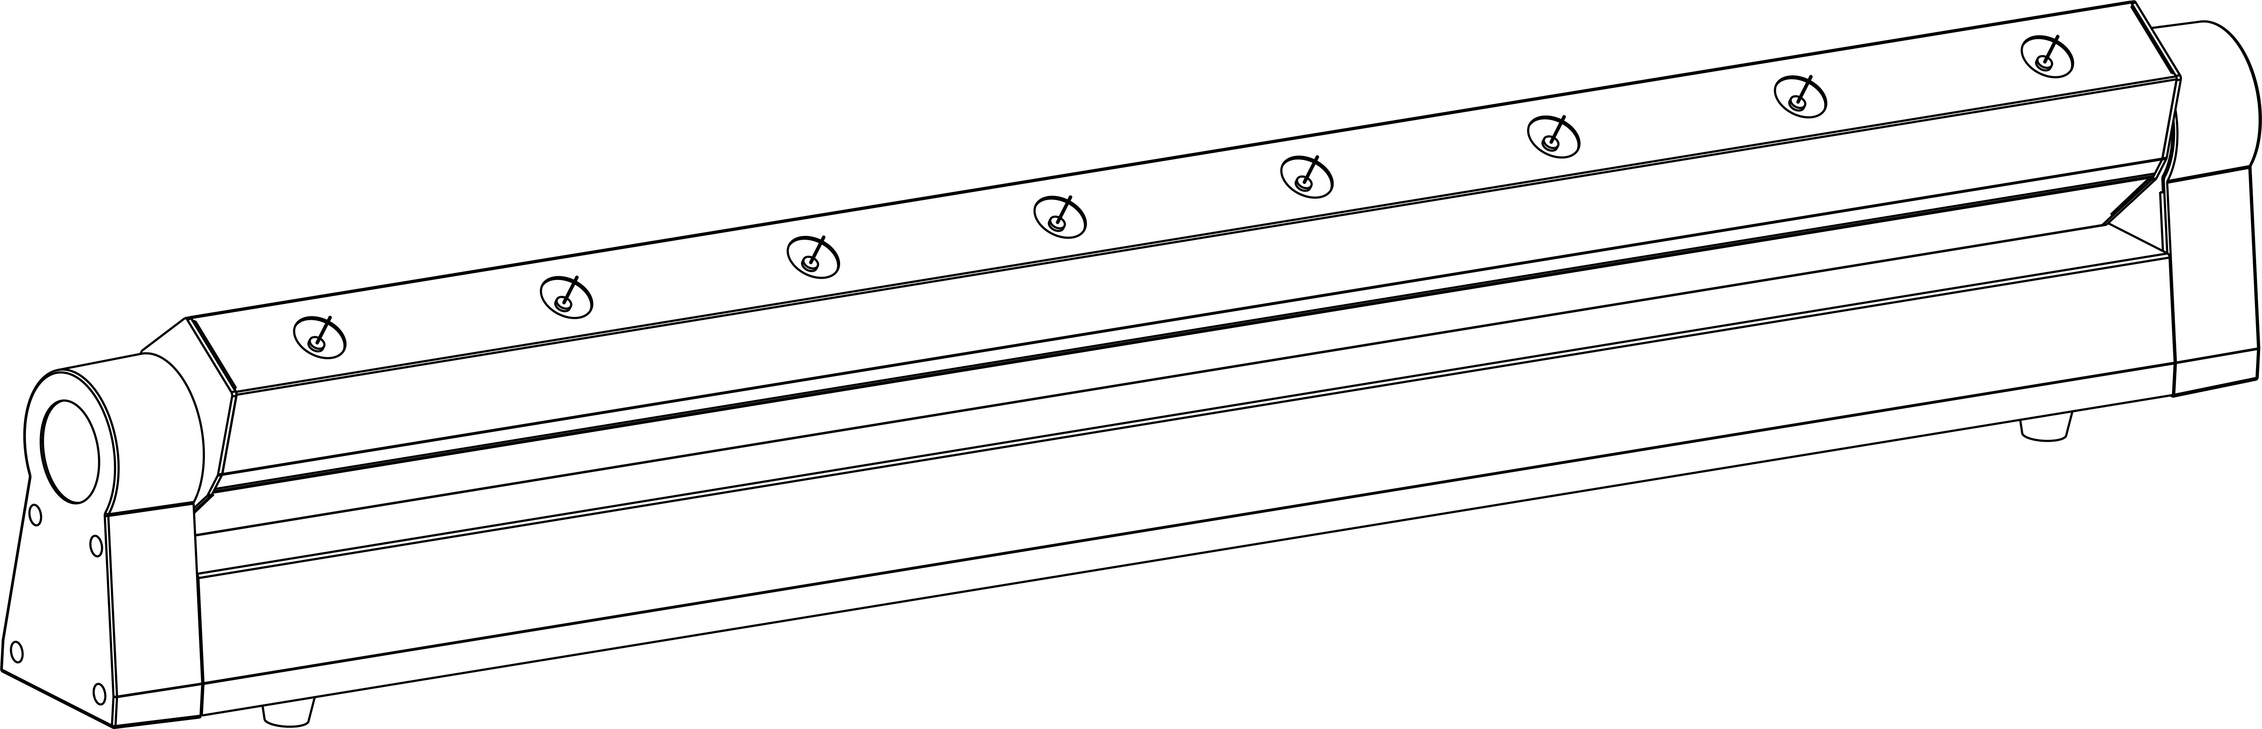

8 Heads Laser Rain

SPL-R/G/B/RGB-506

User Manual

Please read this manual carefully before use!

Thank you for purchasing this product. To optimize the performance of this product,prior to use,please read these operating instructions carefully to familiarise yourself with the basic operation of this unit.Please keep the manual in safe price for future reference.

This unit has been tested at our factory before being shipped to you, there is no assembly required.

Once after received this product , please take and put carefully. And check cautiously that whether the product was damaged or not during the transportation.

Checking Parts
Please check if the following parts are included:
1 x Laser rain
1 x Power cable
1 x User manual

Danger Laser Radiation!

Avoid direct eye exposure!
Laser radiation can cause eye damage or skin damage
All protective measures for a safe operation of this laser must be applied.

Installation

1. Please check the voltage whether is the same with the one showed on the equipment or not.

2. It must ask for the technical person and set the light safety when installation. And let the light beam at the suitable angle.

3. When install this equipment please make sure there's no flammable surfaces (decorated things, etc) within at least 2.5M and maintain minimum distance of 0.5M from the equipment to the walls.

4. Please make sure that there's no other equipment or decorating materials obstructed the exhaust fan and the vent-pipe.

5. Products should be install immobility.
6. In case of safety, it's very important that to connect the earth with line.

Attention

1.Please do not open the bottom cover yourself without permission.Operate it accord the user manual. Call the technician when the machine breaks down.

2.Please do not see the laser beam directly to avoid any damage.

3.Before connect or disconnect the power, please adjust the luminance of the laser diode to the least to avoid any damage to the laser diode.

4.This unit should be keep dry, do not use in the rain and dusty environment. It can be use in the outdoor with the water-proof cover protector.

5. Set the light immobility and try to avoid strong shake or hit.

6.Prevent dust into the equipment to avoid problems.

7.Please keep that there's no other equipment or decorating materials obstructed the exhaust fan and the vent-pipe when the equipment was working.

8.Before connect power, check the plug is immobility or not, power line should be connect well.

9.Please do not open or close the equipment frequently that's to avoid any affect to the life span of the laser diode, and try the best to avoid the long time working.

10.Due to the characteristic of the laser diode, after four hours working, it should be close at least 25 minutes until the laser diode cooling then work again.

11.Don't touch the light or draw the power line when your hand was wet. And do not pull the electronic power line.

12.Maintain the distance at least 3M above from the equipment to the object.

13.This equipment does not have any parts can repair for the users, please do not open the equipment.

14.When the laser diode became dim or damaged please contact the dealer timely.
15.When you want to retransfer the products,you'd better use the original package to shockproof.

Display Function Instruction
1 | Addr | A001-A512 |  | DMX512
2 | Chnd | CH12 |  | 12CH mode
2 | Chnd | CH16 |  | 16CH mode
3 | Slnd | HoSt |  | Master unit
3 | Slnd | SLAV |  | Slave unit
4 | LoSt | AUTO | AU01-AU02 | Auto mode
4 | LoSt | BLAC |  | Keep black
4 | LoSt | HOLD |  | Hold the last scene
4 | LoSt | SOUN |  | Sound mode
5 | SEnS | S001-S100 | 70 | Sound sensitivity
6 | Inv | ON |  | Light reverse
6 | Inv | OFF |  | Light at reset direction
7 | Corr | 0-255 | 127 | Tilt fine correction
8 | DISP | rdon |  | Display no reverse
8 | DISP | rdoF |  | Display reverse
9 | LED | ON |  | LED display ON
9 | LED | OFF |  | LED display off after 13s
10 | Fhrs | 0 |  | Total working time
11 | Deft | YES |  | Set default
12 | u1.4 | u1.4 |  | Software version

Channel Instructions

12CH mode
 |  | DMX-512 value | Function
CH1 | Motor tilt | 0-255 | Tilt
CH2 | Tilt fine | 0-255 | Tilt fine
CH3 | Tilt speed | 0-255 | Tilt speed (fast to slow)
CH4 | Laser off | 0-9 | Laser OFF
CH4 | Laser off | 10-255 | Laser ON
CH5 | laser -① | 0-127 | laser -① OFF
CH5 | laser -① | 128-255 | laser -① ON
CH6 | laser -② | 0-127 | laser -② OFF
CH6 | laser -② | 128-255 | laser -② ON
CH7 | laser -③ | 0-127 | laser -③ OFF
CH7 | laser -③ | 128-255 | laser -③ ON
CH8 | laser -④ | 0-127 | laser -④ OFF
CH8 | laser -④ | 128-255 | laser -④ ON
CH9 | laser -⑤ | 0-127 | laser -⑤ OFF
CH9 | laser -⑤ | 128-255 | laser -⑤ ON
CH10 | laser -⑥ | 0-127 | laser -⑥ OFF
CH10 | laser -⑥ | 128-255 | laser -⑥ ON
CH11 | laser -⑦ | 0-127 | laser -⑦ OFF
CH11 | laser -⑦ | 128-255 | laser -⑦ ON
CH12 | laser -⑧ | 0-127 | laser -⑧ OFF
CH12 | laser -⑧ | 128-255 | laser -⑧ ON

16channels
 |  | DMX-512 value | Function
CH1 | MODE | 0-63 | DMX mode
CH1 | MODE | 64-127 | Auto mode
CH1 | MODE | 128-255 | Sound mode
CH2 | Tilt | 0-255 | Tilt
CH3 | Tilt fine | 0-255 | Tilt fine
CH4 | Tilt speed | 0-255 | Tilt speed(fast to slow)
CH5 | Laser ON/OFF | 0-9 | Laser OFF
CH5 | Laser ON/OFF | 10-255 | Laser ON
CH6 | Laser effect | 0-9 | CH7-CH15 valid
CH6 | Laser effect | 10-255 | Laser flowing effect switch (CH7-CH14 invalid）
CH7 | Laser flowing speed | 0-255 | Laser flowing effect speed (slow to fast)
CH8 | Laser strobe | 0-9 | No strobe
CH8 | Laser strobe | 10-255 | Strobe (slow to fast)
CH9 | Laser -① | 0-127 | Laser -① OFF
CH9 | Laser -① | 128-255 | Laser -① ON
CH10 | Laser -② | 0-127 | Laser -② OFF
CH10 | Laser -② | 128-255 | Laser -② ON
CH11 | Laser -③ | 0-127 | Laser -③ OFF
CH11 | Laser -③ | 128-255 | Laser -③ ON
CH12 | Laser -④ | 0-127 | Laser -④ OFF
CH12 | Laser -④ | 128-255 | Laser -④ ON
CH13 | Laser -⑤ | 0-127 | Laser -⑤ OFF
CH13 | Laser -⑤ | 128-255 | Laser -⑤ ON
CH14 | Laser -⑥ | 0-127 | Laser -⑥ OFF
CH14 | Laser -⑥ | 128-255 | Laser -⑥ ON
CH15 | Laser -⑦ | 0-127 | Laser -⑦ OFF
CH15 | Laser -⑦ | 128-255 | Laser -⑦ ON
CH16 | Laser -⑧ | 0-127 | Laser -⑧ OFF
CH16 | Laser -⑧ | 128-255 | Laser -⑧ ON

Note:Set master-slave: set one unit as master unit at Auto/Sound mode, set slave unit at D001, only 1 master unit for 1 team.

Maintenance

Maintenance should be performed every 15-day period, by using a sponge which is dipped with alcohol, rather than wet cloth or other chemical liquid, to clean the mirror.

Always disconnect from the mains when the device is not in use or before cleaning it.

Warning
Power must be disconnected before maintenance or repair. Do not look at the light source directly

Note

Don't separate laser machine from laser power and repair them by yourself , otherwise no good repair service will be supplied.

Technical Specifications
1.Power Supply: AC 100-240V 50/60Hz
2.Rated Power: 60W
3.Laser Power(6 different versions):
SPL-G-506 Green: 50mw/532nm * 8 ◻
SPL-R-506 Red: 200mw/650nm * 8 ◻
SPL-R-506 Red: 500mw/638nm * 8 ◻
SPL-B-506 Blue: 150mw/450nm * 8 ◻
SPL-B-506 Blue: 500mw/450nm * 8 ◻
SPL-RGB-506 R/G/B: 200mw/650nm*4+50mw/532nm*2+500mw/450nm*2 ◻

4.Working Mode: Sound Active/ Auto-play/DMX512/Master-Slave
5.Control Signal: DMX512 signal
6.DMX Control Channels: 12/16CH

7.Operating Temperature: 10---40℃

8.Storage Temperature: 1---40℃

9.Warm-Up Time :<15 min

10.Laser Classification: 3b

11.Modulation: TTL

12. Scanning angle: 180degrees

13.laser spot diameter: 15mm

14. laser spot ovality: ＞0.9

15.Scanning motor: step motor

Declaration
This device has left our premises in absolutely perfect condition. In order to maintain this condition and to ensure a safe operation, it is absolutely necessary for the user to follow the safety instructions and warning notes written in this user manual.

We cannot be made liable for damages caused by incorrect installations and unskilled operation!

Warranty Card
This product is made of high-brightness transistor. We will provide 1 year warranty under the condition that user has operated the light normally and lifetime service. We won't provide warranty if the damage is caused by artificial or force majeure event. Cost of fittings should be charged by user if product need maintenance after 1 year .Please cut this warranty card and shipped it along with the product to our factory when applying for warranty.
Product： Purchasing date： Code of invoice：
Warranty date: From To
User’s name： Add：
Company： Tel：

